

National University Of Computer and Emerging

Sciences



Assignment # 1 (Thresholding)

Muhammad Moawaz Ayub (L14-4430)

B.S. Computer Science

Instructor: Mr. Mubashir Baig

Department of Computer Science

FAST NU, Lahore, Pakistan

Contents

1. Abstract 3

2. Introduction 3

3. Binarization Methods 3

3.1. Otsu Method 3

3.2. Modifying Histogram 4

3.3. Bernsen Method 4

3.4. Niblack’s Method 5

4. Results 5

4.1. Otsu Method Evaluation: 5

4.2. Histogram Modification Approach Evaluation 6

4.3. Bernsen Method Evaluation 7

4.4. Niblack Method Evaluation 9

5. Performance Evaluation 10

6. Conclusion 11

7. References 11

List of Figures

Figure 1: Edge Model (Taken from Madam Sobia Slides) [2] 4

Figure 2: Using just the mean for thresholding 6

Figure 3: Using Otsu for Thresholding 7

Figure 4: Image where Otsu Fails 7

Figure 5: Image Where Otsu Fails 8

Figure 6: Image where Histogram Modification Beats Otsu 8

Figure 7: Bernsen Method (With Neighborhood size 3*3 and Contrast measure 8) Thresholding Example 8

Figure 8: Bernsen Method with Neighborhood size 3*3 and contrast measure 20 9

Figure 9: Bernsen Method with Neighborhood size 9*9 and contrast measure 8 9

Figure 10: Effect of increasing Neighborhood Size 10

Figure 11: Niblack Method Thresholding with k = -1 10

Figure 12: Niblack method with k = -0.1 and neighborhood size 9*9 11

# Abstract

This Report presents the results of different algorithms for binarizing an image. After comparing some well-known algorithms on ten different images it has been concluded that different algorithms work best for different type of images and no single algorithm work best for all type of images. Our Main focus is to separate foreground text from bright background so our evaluation of these algorithms is based on how well an algorithm separates background from foreground and how much time it requires to binarize the whole image.

# Introduction

Binarizing an image is an important issue which has been addressed in many research papers. The reason for converting an image into a binary image is to extract relevant information for example in the process of OCR our primary focus is to do select characters from image and identify the character so that machine can understand what is written on the paper.

An image usually contains a lot of noise and unwanted patterns so in the process of extracting letters from images we must first choose a threshold value that can used to separate foreground from background. Letters or characters are mostly considered as dark background on a bright background.

In this project we investigate different algorithms that give different threshold for binarizing an image.

1. Otsu Method
2. Modifying Histogram
3. Bernsen Method
4. Niblack Method

The first two methods are for global thresholding that means they give a single value of threshold for the whole image. The last two methods are local thresholding methods which mean for every pixel the threshold value can be different. We have used ten images and tested these algorithms on each of those images.

# Binarization Methods

We have used Otsu, Modifying Histogram, Bernsen and Niblack method to binarize images.

## Otsu Method

Otsu is an unsupervised method that automatically detects an optimal threshold for an image. Otsu method tries to increase between class variance and decrease within class variance. The threshold values that minimizes within class variance can be considered as optimal threshold for the image. The formula for between class variance according to Otsu is given as[1]  (1)

For all the value of k that range from 0 to 255 we compute the formula in equation 1 and the k that gives maximum between class variance is the optimal Threshold.

## Modifying Histogram

Otsu Method tends to take contribution for all images but some time images are very noisy so according to this method only few pixel values should be taken to compute threshold where there is a drastic change in pixel value or the gradient is large enough.

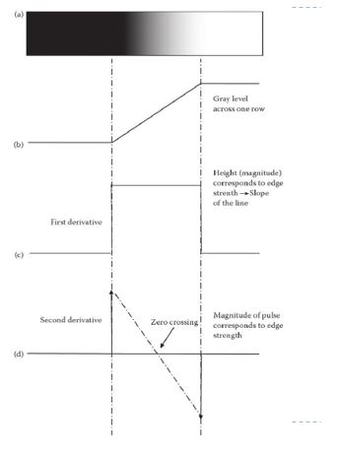

Figure 1: Edge Model (Taken from Madam Sobia Slides) [2]

The second derivative is high where the pixels grey value change drastically as shows in Figure1. So only the pixels where second derivative is high should be considered while computing optimal Threshold for binarizing the image.

## Bernsen Method

Bernsen method falls under the category of Local thresholding which means threshold value has to be calculated on each and every pixel in the image. So in this method  is the threshold at every pixel Z(low) and Z(high) are maximum and minimum value in the neighbourhood. The neighbourhood can be of any size. If the contrast measure  Where l is any number relatively small then this means that Z(low) and Z(high) belong to same class hence they should be considered appropriately.

## Niblack’s Method

Niblack is also a method that computes threshold locally. According to Niblack the threshold is given as the sum of mean and k times multiple of standard deviation. So the Threshold can be calculated as

T(x,y) = m(x,y) + k*s(x,y) (2)

Where m(x,y) is the mean of neighbourhood and s(x,y) is the standard deviation of the neighbourhood system. And the value of k can be selected as -0.1 or less. The size of the neighbourhood selected should be small enough to preserve local details and at the same time large enough to suppress noise.

# Results

## Otsu Method Evaluation:

Otsu Method works best if the image threshold is difficult to calculate by using just the mean of the image. For example in the Figure 2 and 3 you can see the difference of using just the mean and using Otsu method for thresholding.



Figure 2: Using just the mean for thresholding

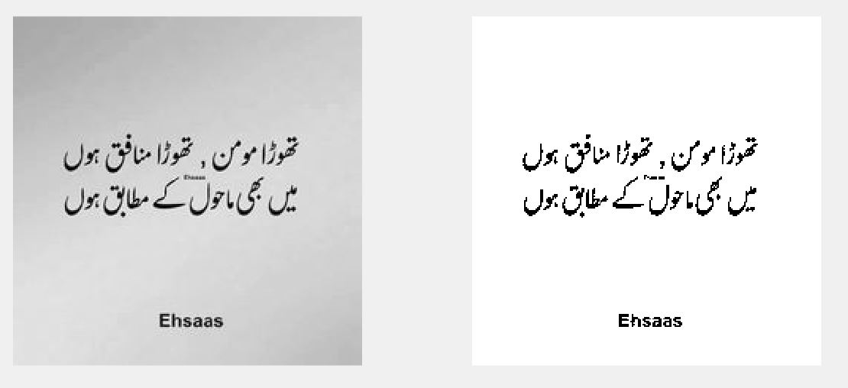

Figure 3: Using Otsu for Thresholding

Otsu Method is best in cases when thresholding Images as shown above but this approach completely fails when some portion of the image is very dark and some very bright as shown in the image below.

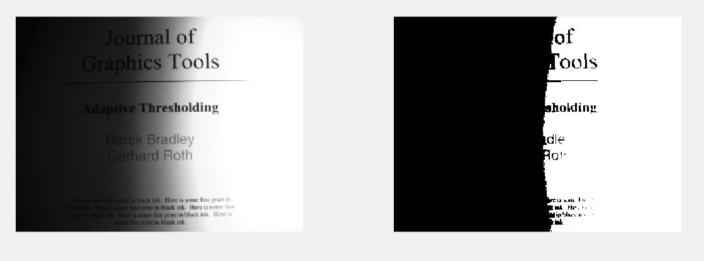

Figure 4: Image where Otsu Fails

## Histogram Modification Approach Evaluation

In this approach only the pixels where there is drastic change is considered. So this Method works better then Calculating mean for Thresholding. This approach beats Otsu Method in some cases where background is dark at some points but not darker then the text and at some points background is light in color.

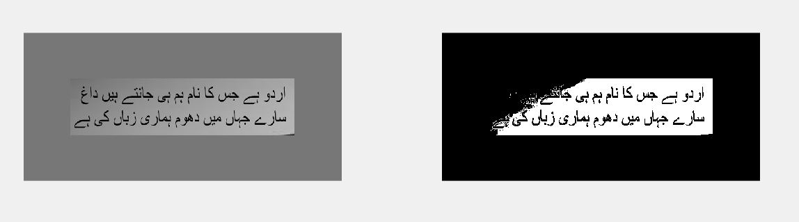

Figure 5: Image Where Otsu Fails

The Histogram Modification method works best in this case as shown in Figure 6 image.

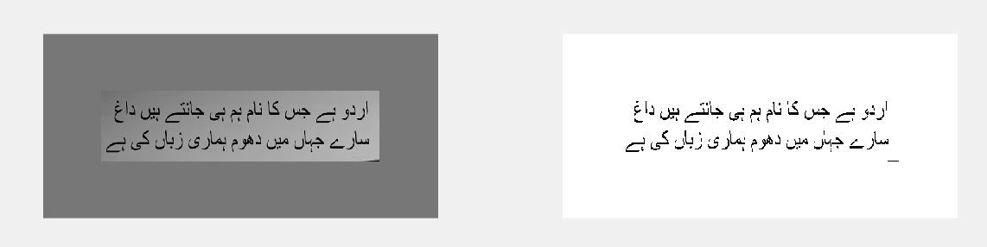

Figure 6: Image where Histogram Modification Beats Otsu

The Histogram Modification works best in this case because only the place where there is drastic change like where the text and light background is located so it will not consider the dark background that is covering the boundaries of the image.

This Approach also fails for images like in Figure 4. So this means that there is a need for local thresholding to solve that problem.

## Bernsen Method Evaluation

Bernsen method [3] is a local Thresholding method so it works well for some images like in Fiqure4.

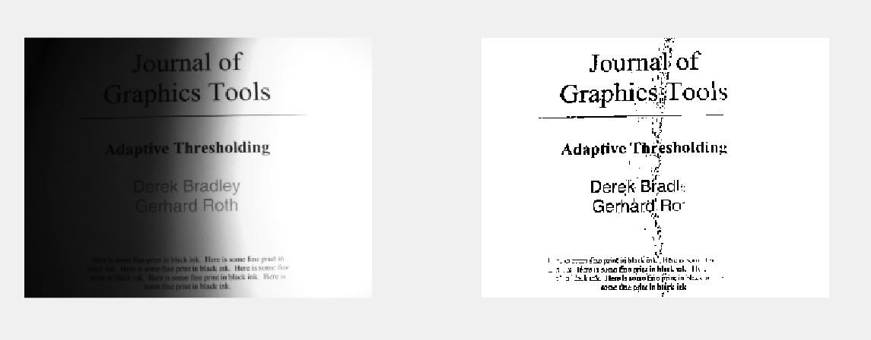

Figure 7: Bernsen Method (With Neighborhood size 3*3 and Contrast measure 8) Thresholding Example

If we increase the contrast measure to 20 then breaks in text starts appearing.

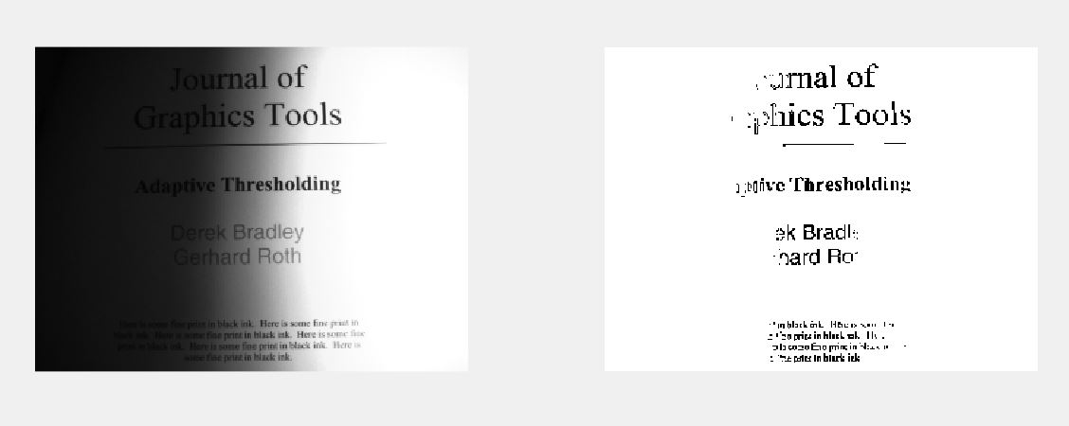

Figure 8: Bernsen Method with Neighborhood size 3*3 and contrast measure 20

As looking at Figure 8 it can be proved that increasing the contrast measure removes most of the noise but at the same time it also breaks the text.

Increasing the Neighborhood size can also improve some images but in some cases it introduces unwanted noise.

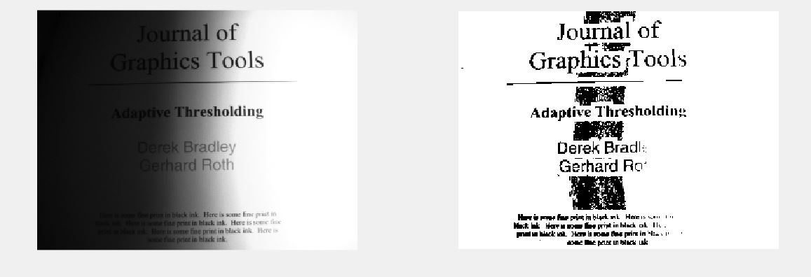

Figure 9: Bernsen Method with Neighborhood size 9*9 and contrast measure 8

As you can see in Figure that increasing the neighbourhood size increase the noise in the images but this is not always the case in some cases increasing the neighborhood size can improve the image as well.

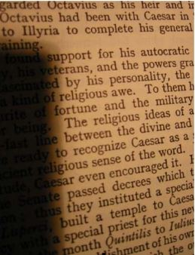

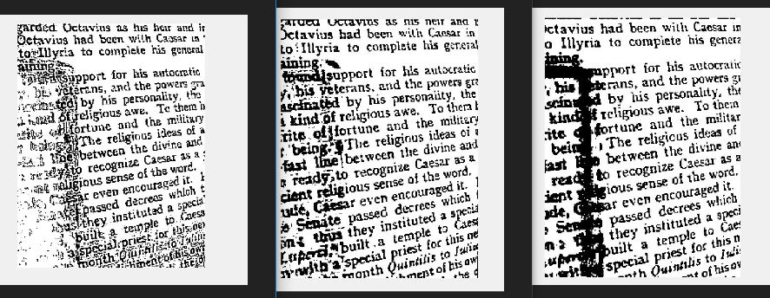

Figure 10: Effect of increasing Neighborhood Size

Neighborhood size is very important in Bernsen method in Figure10 Neighborhood size (9*9) seems most appropriate the Neighborhood size (3*3) and (20*20) are not suitable for this image.

## Niblack Method Evaluation

Niblack is [3] also a local Thresholding method which works best on images like in Fiqure 4

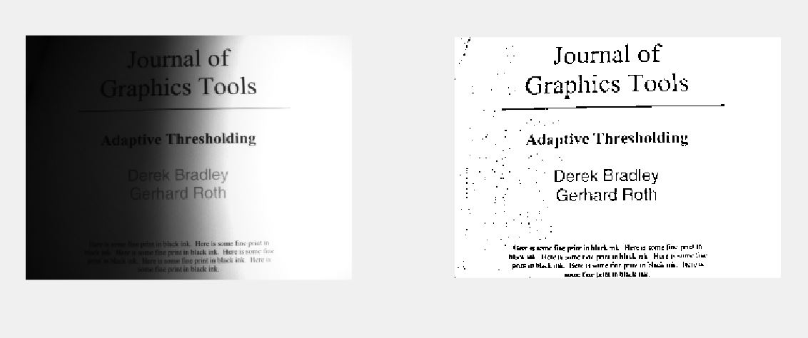

Figure : Niblack Method Thresholding with k = -1

As the value of k is increases the image gets better but also text starts breaking when value of k is two small then then Niblack method introduces large amount of unwanted noise in the image.

As shown in Figure 12.

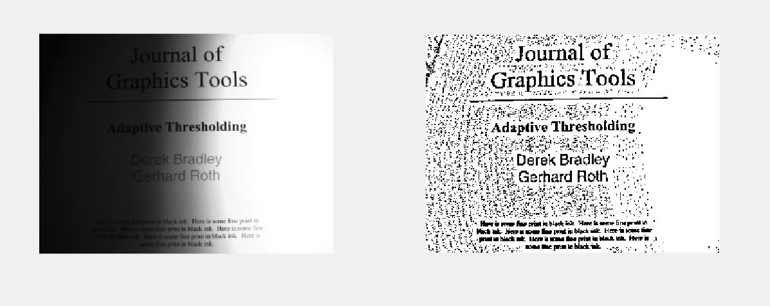

Figure : Niblack method with k = -0.1 and neighborhood size 9*9

Decreasing the neighborhood size in Niblack method also causes lots of unwanted noise in the image.

# Performance Evaluation

It can be said intuitively that global thresholding methods are much faster than local Thresholding methods but these methods fail in case like Figure 4. In such cases local Thresholding methods need to be used which are considerably slow.

# Conclusion

It is very difficult to say that a particular algorithm works best for all types of images because images usually contains lots of variety in it so for some cases some algorithms work best and some work for different type of images. The benefit for using global method is that global methods are very fast but they fail in case of images like Figure 4. Bernsen Methods is very powerful method but it can cause very undesirable behavior sometimes if appropriate parameters like neighborhood size and contrast measure are not set correctly. Niblack methods performs best if the value of k*s(x,y) is reduced by introducing a k that is small enough and neighborhood size should also be appropriate. The Niblack Method works best if it is used with a median filter that removes noise after using this method.

# References

[1] N. Otsu, “A Threshold Selection Method from Gray-Level Histograms,” *IEEE Transactions on Systems, Man, and Cybernetics*, vol. 9, no. 1, pp. 62–66, Jan. 1979.

[2] Madam Sobia Tariq Javed Slides.

[3] O. D. Trier and A. K. Jain, “Goal-Directed Evaluation of Binarization Methods”